2020 Northern Lakes Ducks Unlimited

Tickets @: www.northernlakesdu.org

Fall Banquet

Bluegill Bar 109 S Main Street, Birchwood, WI

Thursday September 17, 2020

Doors Open at 5:30 PM

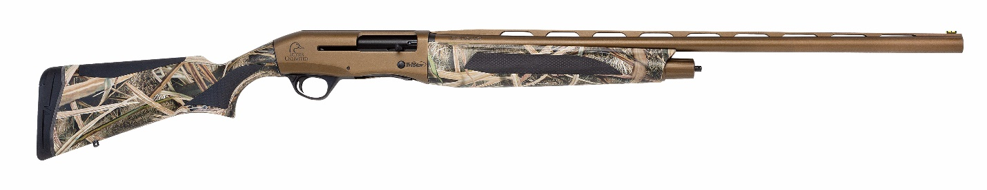**Early-Bird Raffle** – purchase your tickets prior to **September 1st** and receive a chance for a Tristar Viper Max 12-gauge shotgun.

**Single Ticket: $50.00**

• Includes: Dinner, DU Membership and chance on door prize.

**Sponsor Ticket: $300**

• Includes: Dinner, DU Sponsor Membership, Framed DU WI Sponsor print, Sponsor only Raffle.

**Table of 8: $800**

• Includes: 8 dinners, memberships and each person will receive $50 in Duck Buck PLUS - 1 person will get **Choice** off our Sportsman Gun Banner or Yeti 65.

**Underwrite an Item for our event**: $50, $100, $150

* Your name will be displayed as donated by you or your business.

If you would be willing to join our committee or need more information, contact:

-Matt Lavick: 715-205-6007 - David Ohms 509-979-1585 – Bill Grab: 920-321-8155

**Please return this portion with your payment or www.northernlakesdu.org**

**Qty. Total**

**Single Dinner $50 each ______* $_________**

**Sponsor $300 each** **______ $_________**

- Includes: Dinner, DU Sponsor Membership, Framed DU WI Sponsor print, Sponsor only Gun Raffle (1 in 10).

**Gun / Yeti Table of 8 - $800 (circle choice)** **______** **$_________**

- Includes: 8 dinners, memberships and each person will receive $50 in Duck Buck

PLUS - 1 person will get Choice off our Sportsman Gun Banner or a Yeti 65.

Greenwing (17 and Under) **$35.00** **each** **______ $_________**

**Total Amount $_________**

Credit Card _____________________________________________CVV _____________

Exp. ____________ Signature: _________________________________

Name_________________________________________________________________

Address_______________________________________________________________

City/State/Zip___________________________________________________________

Telephone Number______________________________________________________

Please make checks out to **NLDU** and send to the following address:

Northern Lakes Ducks Unlimited

PO Box 39

Birchwood, WI 54817

*If you are purchasing a table or paying for more than 1 membership please list the names of the people you are paying on a separate paper and mail back with order. Please indicate by each name, address, phone and email address.