Catered by Jean Gagne  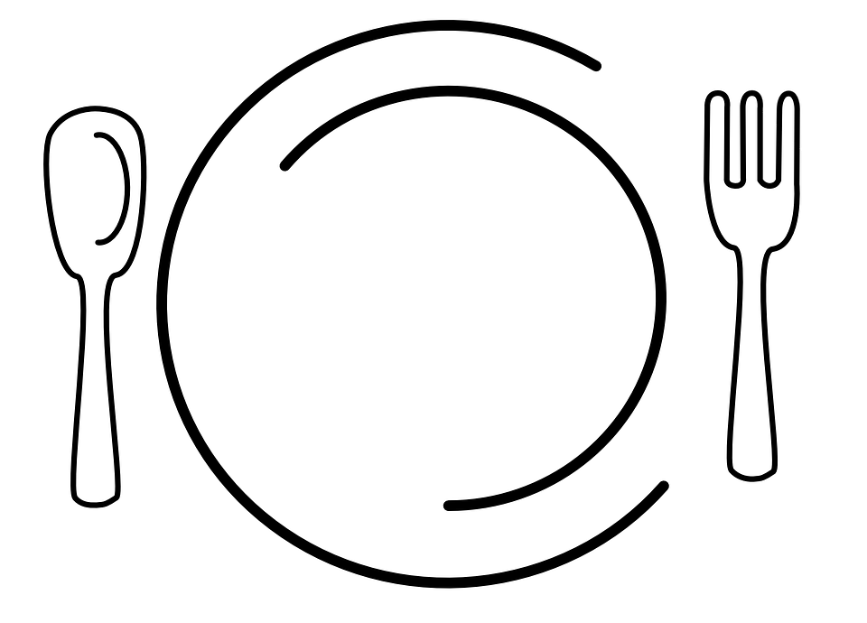  Main Course  Server plated and Socially Distanced Buffet  - Stuffed Chicken Breast  - Maple Glazed Ham  - Bacon Mac and Cheese  - Lemon Pepper Seasoned Vegetables.  Sides  - Caesar Salad  - And Jean’s Signature Sour Cream Dinner Rolls  Dessert  An assortment of Cheese Cakes and Toppings  Bar Service by  Mill River Brewery | We are proud to recognize these local donors, supporters, and national brands for contributing to this event:  - Hotel Vermont  - La Bella Derma  - Smugglers Notch  - Bauer, Gravel, Farnham LLP  - Happy Bird Poultry Farm  - Hen of the Wood  - The North Hero House  - Vermont State Parks  - E. P. Gagne Decoyeur  - Charlie Barsalow Auctioneer  - Shore Acres  - Higdon Decoys  - Lost Nation Guns and Ammo  - As The Crow Flies  - The Village Frame Shoppe  - Drake Waterfowl  - Jay Peak Resort  - Complete Septic Service  - Due North Vineyard  Thank you for your Support! | 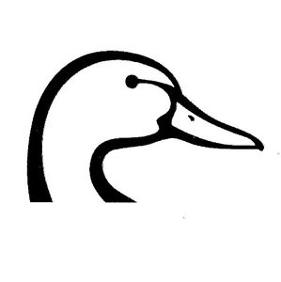  The Lake Champlain Islands Chapter of  Ducks Unlimited  Invites you to join us for our  Annual Dinner Event  Saturday, March 26th 2022  NEW LOCATION!!!  North Hero Community Hall  US-2 North Hero VT  05474  Right next to Hero’s Welcome!  Doors open at 4:00pm  Dinner at 5:30pm
Early Bird Registration  The Early Bird deadline is  March 12th  All Early Bird registrants will be entered into a drawing for two $100 raffle ticket packages  ***  We will be mindful of Covid precautions.  ***  Masks will be available for those that wish to wear them.  To RSVP contact Ed Gagne  by phone or email  802-752-0909  decoykid@hotmail.com  56 Elm St Enosburg Falls VT 05450 | Event Tickets  Single Event Membership $65  Couple Event Membership $100  Sponsor Event Membership $290  Sponsor Couple Event Membership $300  Executive Sponsor Event Membership $500  Greenwing Event Membership  (ages 17 and under) $35  ***  All tickets include your meal at the event  ***  Executive Sponsors, Sponsors and Greenwings will be entered into respective raffles based on their event ticket!  ***  For every seven sponsor memberships sold at the event, a gun will be drawn from our 52 gun banner!  ***  Can’t make it to this year’s event?  Membership Only Prices  Single Membership $35  Sponsor Membership $250  Greenwing Membership $15 | Play to Win!  - Lucky Duck Raffle  Raffle Packages at the Event  - $20 - 1 page of general raffle tickets and 1 bonus raffle ticket  - $50 - 3 pages of general raffle tickets and 3 bonus raffle tickets  - $100 - 6 pages of general raffle tickets, 6 bonus raffle tickets.  Buy your raffle tickets ahead of time and save!  - $15 - 1 page of general raffle tickets and 1 bonus raffle ticket  - $45 - 3 pages of general raffle tickets and 3 bonus raffle tickets  - $90 - 6 pages of general raffle tickets.

