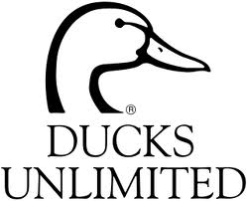

***2022***

***DUCKS UNLIMITED MEMORIAL BBQ***

***TO HONOR THE FRIENDS WE LOST THIS YEAR JIM BERKLAND, GARY HARRIS & CHUCK SHEPARDSON***

Thursday August 18th, 2022

The Event is at Santa Clara County Horsemen’s Association, 20350 McKean Rd San Jose, CA 95120 Hors d’oeuvres and a Dinner grilled to perfection, a hosted “Top Shelf” bar, not to mention the company of some of the most fun loving duck hunters in the world. Cocktails and Hors d’ oeuvres @ 5:30 PM. Dinner promply @ 7:00 PM.

**Count Me In!** I am a 2022-2023 sponsor at: ___________________________(chapter)

**Count Me In!** Enclosed is my 2022-2023 DU sponsor donation or Sponsor Upgrade: Gold $1000______ Silver $500_______ Bronze $250_______ **Guest with Sponsor $50**_________ (American Express, Discover, MasterCard or Visa) Please include your account CC#_________________________________

Expiration Date_______________________3 digit V Code off the back of the card_________

**I am already a sponsor and will attend and will donate $40.00 to offset the costs of this event or make a donation in the amount of**  $________

Name_______________________________Street____________________________

City_________________________________State___________Zip_______________

Phone_______________________________email____________________________

email: [**ducksunlimitedsanjose@yahoo.com**](mailto:ducksunlimitedsanjose@yahoo.com)OR mail to: Ducks Unlimited 1536 Camden Avenue, Campbell, CA 95008. Remember we are limited to the first 100 Responses.