Lancaster Super Bowl Pre “Game” February 11, 2022 5:00pm - 9:00pm Melhorn Manor

977 West Main Street Mount Joy, PA 17552



Scan QR Code For More Details and Tickets

Attendance Not Required to Win!!

Ticket Cost: $25 Includes Admission / 1 Entry Or 5 Entries for $100 and 5 Admissions!! Purchase the

$100 Package and be Entered Into an Incentive Gun Raffle

Admission includes: Beer, Soda and FREE Wild Game Dishes to Enjoy - Cash Bar will also be Available

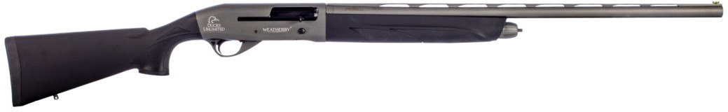

3. Weatherby Element Tungsten 12 GA

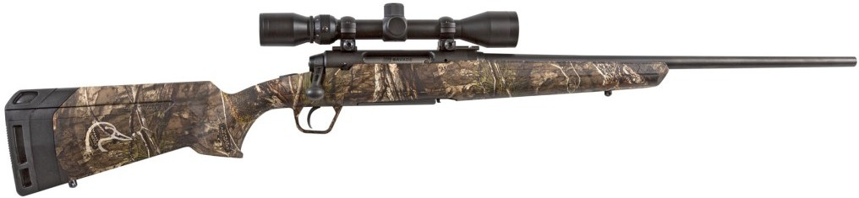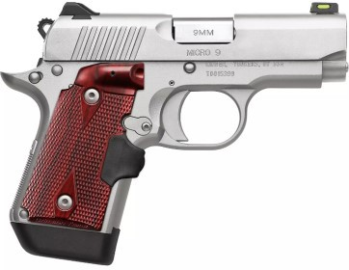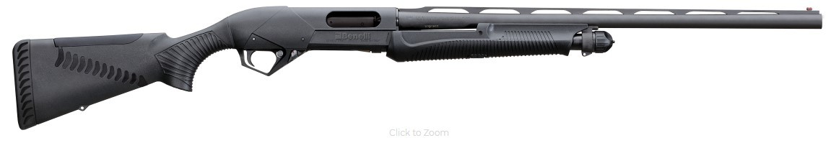

4. Kimber Micro 9 Stainless

6. Benelli Super Nova 3.5” 12 GA

8. DU Savage Axis XP

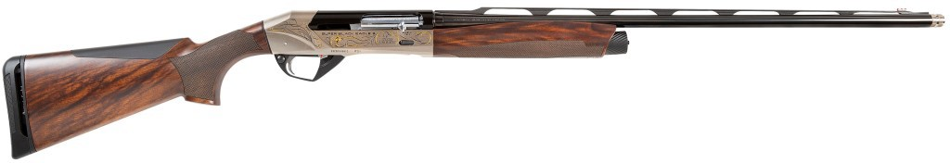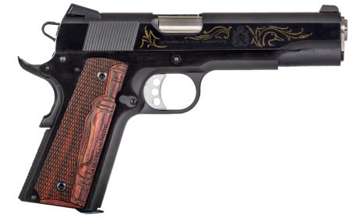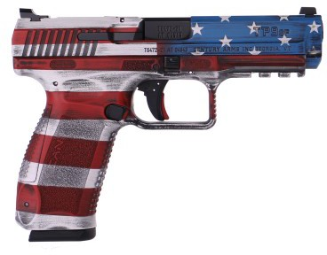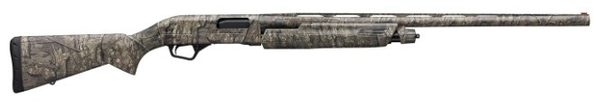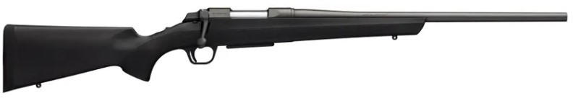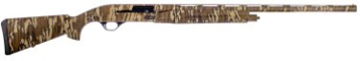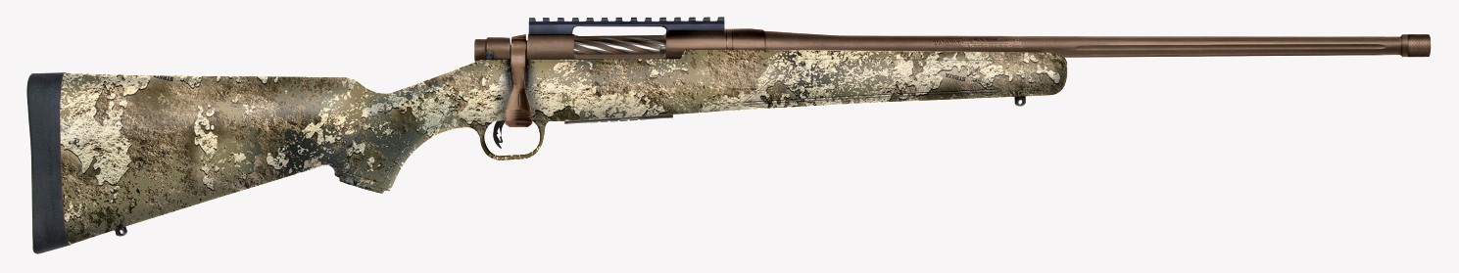

1. DU Benelli Super Black Eagle 20 GA

2. Springfield Garrison 1911 .45 APC

5. Mossberg Patriot Predator .243 Bolt

7. DU Canik TP9

9. Winchester SXP 12 GA

10. Browning ABolt .308 Rifle

Incentive Gun : Retay Gordion

Need Not be Present to Win!!

For More information Contact: Chad Hohenwarter (717) 201-1600

This Event Sold Out Last Year!!!

OPEN TO THE FIRST 200 ATTENDEES!!!

|  |  |  |
| --- | --- | --- |
| ______ Single Tickets ($25) # Attending | X $25 | = _________ |
| ______ $100 Packs ($100) # Attending | X $100 | = _________ |
| Includes: 1 Chance on the Incentive Gun: Retay Gordion 12 GA  _ $175 Widgeon Raffle Package (MUST ATTEND TO PURCHASE!!!) | X $175 | = _________ |
| Includes: 1 Attendance Ticket, Extra Ticket for the 10 Prize Drawing, |  |  |

DU Membership, $300 worth of General & Bonus Raffle Tickets, and 1 chance for a pair of Full Size Bryon Bodt Widgeon Decoys

The Number of ATTENDEES MUST be Written Down!!!

Total :

= _________

**Name:** **Address:** **City:** **State:** **Zip Code:** **Phone:** **Email:**

**Credit Card: MC Visa AMEX Discover**

**CC#:**

**Exp. Date:**  **CVV Code:**

**Signature:**

Make Checks Payable to: Ducks Unlimited Return Completed Forms to:

Dave Eller 3618 Wildflower Lane, Mountville, PA 17554