**BIG MAMA’s and STURGIS DUCKS UNLIMITED**

**2023 Sturgis Rally Great Gun Raffle**

**Bersa Thunder 380 Purple Pistol
** 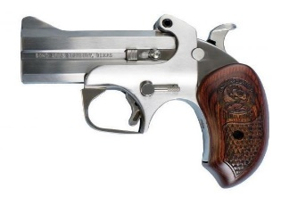 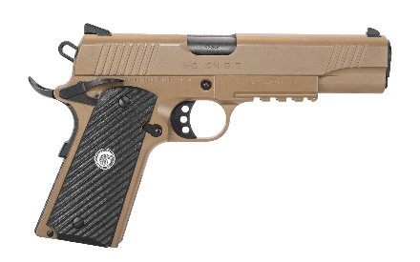

Bersa Thunder 380 Purple Pistol Bond Arms Snake Slayer 410 Bore 45 Colt EAA MC1911S 45ACP FDE

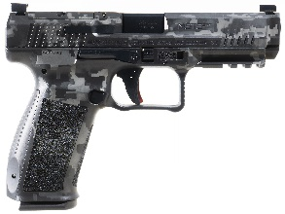 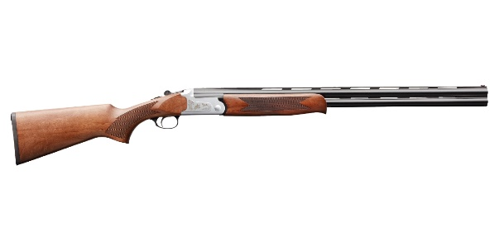 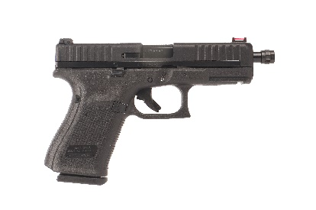

Canik METE SFT 9MM Grey DIGI Charles Daly 202 White Over Under 410 Glock G44 22LR

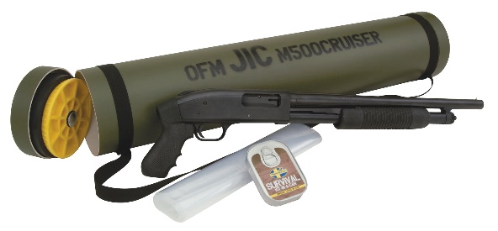 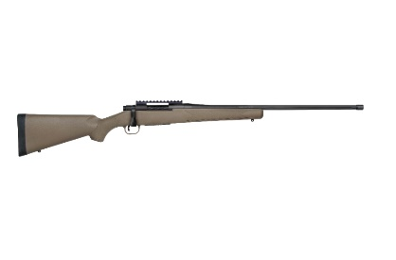 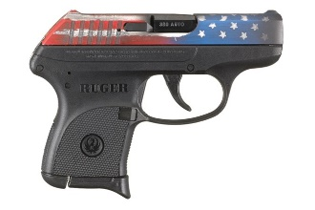

Mossberg J.I.C 12ga Shotgun Mossberg Patriot Predator 7mm PRC Rifle Ruger American Flag Slide 380ACP

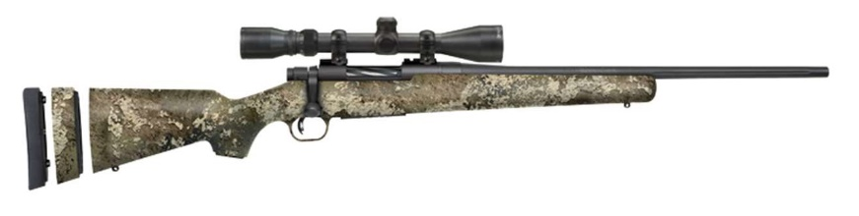 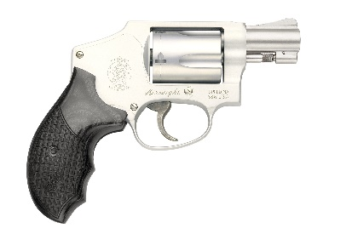

Mossberg Patriot SPR 7mm-08 Rifle Smith&Wesson 642 Deluxe 38 Special

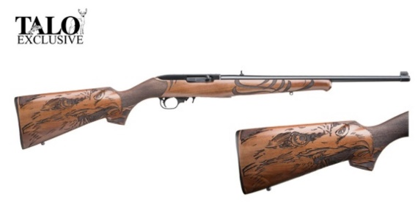 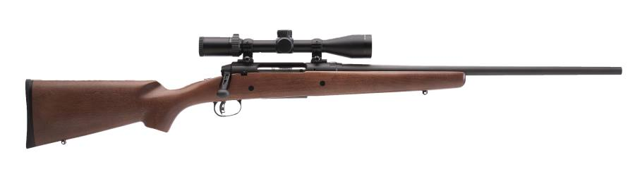

Ruger 22 LR Engraved Eagle Rifle Savage Axis II 30-06 Rifle

***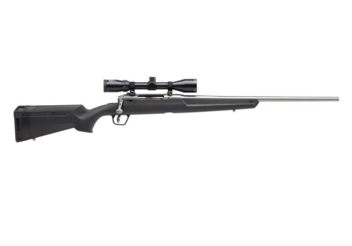******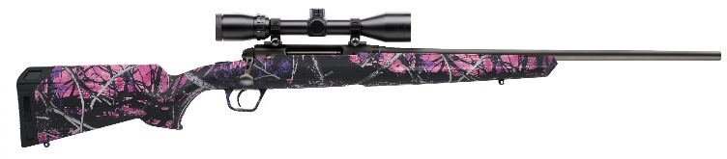***

Savage Axis II XP 6.5 Creedmoor Rifle Savage Axis XP Muddygirl 7mm-08 Rifle

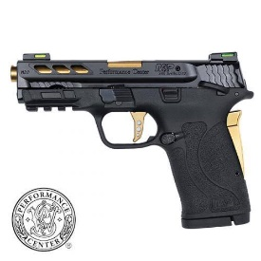 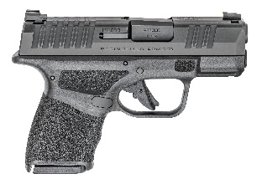 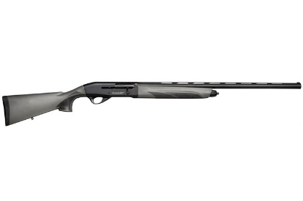

Smith&Wesson M&P 380 Shield EZ PC380ACP Spring Hellcat 9mm Weatherby Element Synthetic 20ga Shotgun 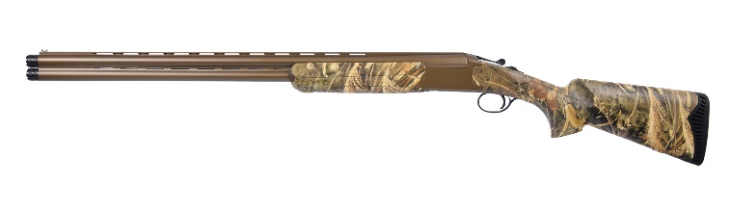

Pointer Acruis O/U 20ga Shotgun