**Putnam Ducks Unlimited Sportsman’s Night Out!**

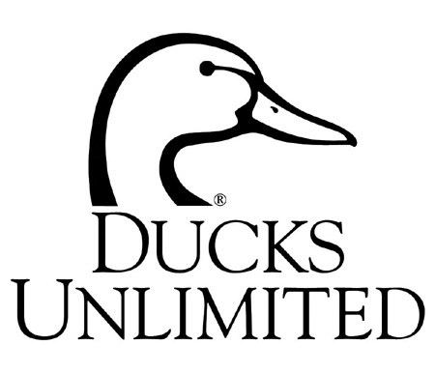

RAFFLES!! FIREARMS!!

LOTS OF PRIZES!!

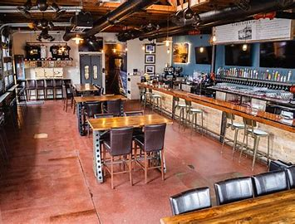

**Sportsman’s night out Cookout & BEER**

###### Saturday June 29, 2024

3:00 pm

Lebanon Tap Room

385 Beaumont Hwy

Lebanon, CT 06249

Tickets $50 in advance /

$60 at the door

Join us for a fun, family friendly event to kick off the summer! Your ticket includes food, sides, beer, and beverages! Round up the family and friends and join us for great raffles and fun!

**\*\*\*\*RAFFLE PACKAGE SPECIAL\*\*\*\***

**Early Bird Raffle Package** - Receive $200 in raffle tickets for $100**! The first 50 reservations for a raffle package will receive $200 in raffle just $100**. Packages are on a first come, first serve basis. Order fast to be one of the first 50!

**Sponsor Package** - $320 Includes One Event Ticket, DU Bronze Sponsorship and $200 in Raffle Tickets.

Scan the QR code to see our other raffles or to register online.

**\*\*\*\*\*\*\*\*\*\* REGISTER EARLY AND BRING YOUR FRIENDS\*\*\*\*\*\*\*\*\*\***

Event tickets and raffle tickets will be picked up at the door when you pre-register.

***Pre-Registration Form: ….✄…………………………………………………………………………………….***

Name: ________________________________________

Address: ______________________________________

City: ________________________ St: _____ Zip: _____

Phone: (____) - ________ - _________

**Please list all additional attendees on a separate piece of paper and include their name and address along with your registration form.**

Credit Card: Visa MC Discover AmEx

CC#: _______________________________________

Exp Date: _____________ 3-digit code on back __________

Signature: ______________________________

**Return completed reservations to:** Putnam Ducks Unlimited, C/O Mike Compo, 7225 Number 4 rd, Lowville NY, 13367

___ Individual Event Tickets @ $50 ………….$ ______

___ Kids 12-18 @ $30 ……………………….$ ______

__ Kids 11-and under – FREE ……………….$ ______

___ Early Bird Raffle packages @ $100 …… $ ______

(raffle package only, does not include event ticket)

___ Sponsor Package @ $320 …………...... $______

TOTAL……………………………………. $ ________



#### Putnam DU

Pig Roast

Sunday, June 4, 2023

