**Bluestem Chapter of Ducks Unlimited**

***BINGO***Night at***Frawg’s Bar & Grill***

307 S. Haverhill Road

El Dorado, KS. 67042

**Date:** November 12, 2024 (Tuesday)

**Time:** 6:00 PM – 9:00 PM

**Cost:** $35.00 per person

***Event starts at 6:00 PM for social, attendees are welcome to order food off Frawg’s outstanding menu (meal is not included). Bingo will start at 7:00 PM***

**Included w/ Ticket**: *Five BINGO Cards, one per game, Draft Beer until it’s gone.*

* **There will be five (5) games of BINGO played. The person who BINGO’s will be the winner of that game. Each game will have one winner and only one gun or item. In the event of a tie or multiple bingo’s, we will have those who have a valid BINGO, draw from a deck of playing cards, highest card is the winner of that game.**
* **Players will be able to purchase additional BINGO cards per game for $10 per card.**
* **There will be a silent auction going on during this event and FIVE (5) chances at winning a gun or a Turtlebox Speaker:  MUST BE PRESENT TO WIN!!!**

**You must have a ticket to the event to bid on silent auction items or get BINGO chances at winning guns.**

Contact any Bluestem Chapter Board or Committee Member for tickets!!!!

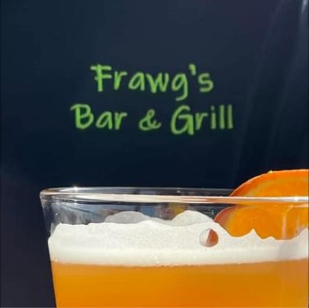

**Chris Megredy** (Area Chair)– **316-258-7401**

**Thenia Megredy** (Co-Chair)– **316-832-8195**

**Nathen Drake** (Treasurer) **– 316-323-4630**

**Angie Starkey** (Secretary)– **316-322-0644**

**Scott Starkey** (District/Central Flyway Chairman)**– 316-206-3133**